AI-Education 2025 Conference Proceedings Submission Guidelines

Please format your Conference Proceedings paper according to the following guidelines, style checklist, and paper template, and submit it through the Online Submission System (CMT). Papers that do not follow these formatting rules will be returned for editing.

Article structure

Please use the article structure outlined below.

Title

Ensure that your title accurately reflects the contents of your paper and is free of errors.

Abstract

A concise and factual abstract is required (maximum length of 500 words). The abstract should state briefly the purpose of the research, the principal results and major conclusions. References should be avoided, but if essential, then cite the author(s) and year(s). Also, non-standard or uncommon abbreviations should be avoided, but if essential they must be defined at their first mention in the abstract itself.

Keywords— (3–5 keywords, separated by commas)

Introduction
Present purposes of the study and provide background for your work.

Conclusion
The main conclusions of the study may be presented in a Conclusion section, which can include the main findings, the implications, and limitations.

Acknowledgements
Gather any acknowledgements in a separate section at the end of the article before the references and do not include them on the title page, as a footnote to the title or otherwise.

Footnotes
Footnotes should be used sparingly. Number them consecutively throughout the article, using superscript Arabic numbers.

References

In-text citations
Please ensure that every reference cited in the text is also present in the reference list (and vice versa).

Reference style
Within the text: citations in the text should follow the referencing style used by the American Psychological Association (APA). Publication Manual of the American Psychological Association, Sixth Edition, ISBN 978-1-4338-0561-5.

List at end of paper: References should be arranged first alphabetically and then further sorted chronologically if necessary. Please single space, and indent after the first line of each.

Reference to a journal publication:
Kasneci, E., Sessler, K., Küchemann, S., Bannert, M., Dementieva, D., Fischer, F., & Kasneci, G. (2023). ChatGPT for good? On opportunities and challenges of large language models for education. Learning and Individual Differences, 103, 102274.

Reference to a book:
Russell, S., & Norvig, P. (2021). Artificial Intelligence: A modern approach (4th ed.). Pearson.

Reference to a chapter in an edited book:
Woolf, B. P. (2010). Building intelligent interactive tutors. In R. J. Kreuz & M. S. MacNealy (Eds.), Empirical methods for artificial intelligence in education (pp. 135–160). MIT Press.
Style checklist:

- APA Style - http://bit.ly/APAguide

- 12-point Times New Roman font.

- All paragraphs and body text justified and single spaced.

- One line should separate paragraphs or sections. Do not indent paragraphs.

- Set page size to A4.

- Margins: Top & Bottom – 2.54cm; Left & Right – 3.17cm (Office 2003 Default).

- Manuscripts not to exceed 5,000 words each (excluding tables, figures and references). Manuscripts longer than 5,000 words will be returned for editing.

- Main headings, subheadings and sub-subheadings should be formatted as in the example below. No more than three levels of headings should be included.

- All figures and images must be inserted in a JPEG image format, within the page margins. Centre images. Do not insert loose objects such as arrows, lines or text boxes. Number and caption below the figure (Figure 1: Caption), centre aligned.

- Tables should be created within the Microsoft Word document, should fit onto one A4 page and should be numbered and captioned below the table, centre aligned.

- Bold any section/paragraph headers and left align.

- Do not use any page headers, footers or page numbers (footnotes are acceptable).

- Use only portrait layout. Do not include any pages in landscape layout.

- Corresponding author contact email address may be added to the end of the paper after references. AI-EDUCATION2025 is not responsible for unsolicited emails received.

- An optional Acknowledgments (max. 150 words) may be included as the last section before reference list.

- Title page information to include:
  - Title of the paper
  - Author names and affiliations: Provide authors' affiliation details (where the work was done) including full institution name and country.
  - Abstract: A concise and factual abstract not exceeding 500 words is required.
  - Keywords: Immediately following the abstract provide a minimum of three keywords.

Title of Paper

First Author¹, Second Author²
¹Affiliation, City, Country — email@email.com
²Affiliation, City, Country — email@email.com (if applicable – max 5 authors)

Full Name of Conference (including year)
Official Conference Proceedings

Abstract (Maximum of 500 Words)
Insert your abstract text here – up to 500 words, single-spaced, justified.

Insert the new paragraph here.

Keywords— (minimum of 3)

Introduction

Insert your introduction text here.

Insert the new paragraph here.

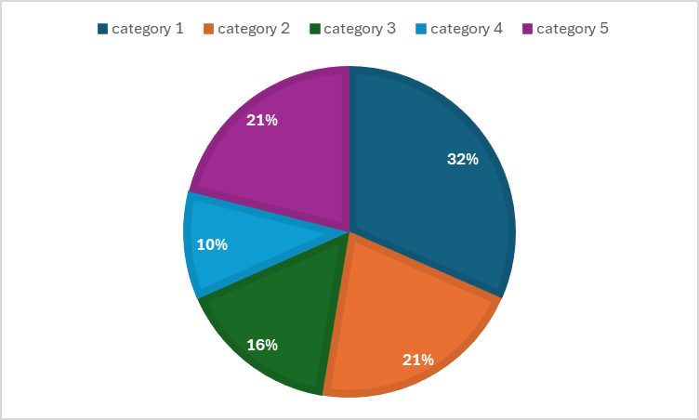
Figure 1: This is an image.

Conclusion

Insert your conclusion text here. Summarize the main findings, implications, and any limitations of your study.

[Referencing / Bibliography to start on a new page – Please delete]
References

Kasneci, E., Sessler, K., Küchemann, S., Bannert, M., Dementieva, D., Fischer, F., & Kasneci, G. (2023). ChatGPT for good? On opportunities and challenges of large language models for education. Learning and Individual Differences, 103, 102274.

Russell, S., & Norvig, P. (2021). Artificial Intelligence: A modern approach (4th ed.). Pearson.

Woolf, B. P. (2010). Building intelligent interactive tutors. In R. J. Kreuz & M. S. MacNealy (Eds.), Empirical methods for artificial intelligence in education (pp. 135–160). MIT Press.

Contact email: example@example.gr (optional)

